
Course Description:

Intro to Coding will offer students an opportunity to explore computer programming through a user-friendly environment. This is a free and open source course to learn programming in Python, and is intended to create interest in programming as a hobby and possible a career. Students will learn this by using the Python programming language through the editor Visual Studio Code.

Topics Covered:

Basic Python Commands and programs
Conditionals
Loops and Lists
Python Functions
Object Oriented Programming/Class and Object creation
Python Graphics using the Processing Library

Class Rules:

Respect others, respect the teacher, and respect yourself.
Give honest effort in everything you do.
Ask for help whenever you need it. Help will always be given here to those who ask for it.
Work well with others.
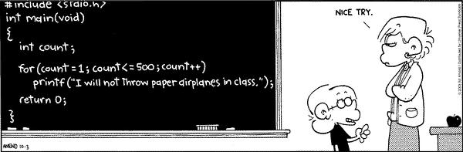

Grading System:

Labs: | 60%
Unit Projects: | + 40%
 | 100%

Grading Scale:
A 4.00 – 3.65
A- 3.64 – 3.50
B+ 3.49 – 3.35
B 3.34 – 3.15
B- 3.14 – 3.00
C+ 2.99 – 2.85
C 2.84 – 2.65
C- 2.64 – 2.50
D+ 2.49 – 2.35
D 2.34 – 2.15
D- 2.14 – 1.99
There will be a standards based grading scale for this class,
with 4 showing mastery of the content, 3 being proficient,
2 being nearly proficient, and 1 being needs attention.
These are the averages that equate to each letter grade.

Instructional Videos and examples:
In an attempt to help create a class that is self-paced, there is a series of videos that have been created to help guide students through the course. These videos can be found on the Code Dog YouTube channel. Students can watch to learn concepts, repeat videos for extra explanation and focus, and complete the example files for practice at each lesson throughout the course.

Labs:
Labs are the tool that will be used to learn the content. Each lesson that we do will have a lab to be completed that takes the main concepts from that lesson and applies them in a program that the student creates. Students are encouraged to be creative with their solutions to the labs, and show a deep understanding in their solving of the problems presented.

Projects:

Unit Projects are the replacement for “tests” in this course. At the end of each unit, students will create a program that combines all of the major concepts taught in all of the lessons throughout the unit. These are meant to be longer and more involved, helping show mastery of the different learning objectives we wish to cover. While students will have ample time to begin projects in class, it may be necessary for students to work on them at home or during student assistance time if they do not have access to a computer. I encourage students to contact me through email if they have any difficulties.

Contacting me:

The best way to contact me is by e-mail (bmyerscough@riverviewschools.com). I check school e-mail throughout the day and will try to respond that same day. Schoology messages are usually more unreliable and I don’t always get them the same day, but I will respond there when I can as well.

